**Kubernetes Setup using Kubeadm**

**~Start - Execute the below commands in both Master/worker nodes**  
  
**Login to both instances execute the below commands:**  
sudo apt-get update -y  && sudo apt-get install apt-transport-https -y

**Change to root user**

sudo su -  
sudo curl -s https://packages.cloud.google.com/apt/doc/apt-key.gpg | apt-key add -  
  
cat <<EOF >/etc/apt/sources.list.d/kubernetes.list  
deb https://apt.kubernetes.io/ kubernetes-xenial main  
EOF  
  
sudo apt-get update  
  
**#Disable swap memory for better performance**  
swapoff -a  
sudo sed -i '/ swap / s/^\(.*\)$/#\1/g' /etc/fstab

**Enable IP tables**  
#We need to enable IT tables for pod to pod communication.

modprobe br_netfilter  
sysctl -p  
sudo sysctl net.bridge.bridge-nf-call-iptables=1

**Install Docker on both Master and Worker nodes**  
apt-get install docker.io -y

**Add ubuntu user to Docker group**

usermod -aG docker ubuntu  
systemctl restart docker  
systemctl enable docker.service

Type exit to come out of root user.  
**Install Kubernetes Modules**  
sudo apt-get install -y kubelet kubeadm kubectl kubernetes-cni  
  
sudo systemctl daemon-reload  
sudo systemctl start kubelet  
sudo systemctl enable kubelet.service

sudo systemctl status docker

**#End - Execute the above commands in both Master/worker nodes##########**

cd /etc/docker/

vi daemon.json

add this below commands:-

{

"exec-opts": ["native.cgroupdriver=systemd"]

}

**sudo systemctl daemon-reload**

**sudo systemctl restart docker**

**sudo systemctl restart kubelet**

**Wait for Sometime, It will take some time**

**Initialize Kubeadm on Master Node(only on Master Node)**  
  
#Execute the below command as root user to initialize Kubernetes Master node.  
sudo su -  
kubeadm init

[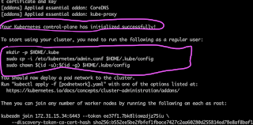](https://1.bp.blogspot.com/-n_JMv8yrHxs/Xv1UaPiJ_TI/AAAAAAAACyQ/HXjGmVkVd_4TB41BdOXkLZC0OhAYTUfRwCLcBGAsYHQ/s1600/k8s.png)

Make sure you see the above message to confirm master node is up.  
  
#Now type exit to exit from root user and execute below commands as normal user  
  
mkdir -p $HOME/.kube  
sudo cp -i /etc/kubernetes/admin.conf $HOME/.kube/config  
sudo chown $(id -u):$(id -g) $HOME/.kube/config

**Installing the Weave Net Add-On**  
kubectl apply -f https://github.com/weaveworks/weave/releases/download/v2.8.1/weave-daemonset-k8s.yaml

It make take a few mins to execute the above command and show show the below message.

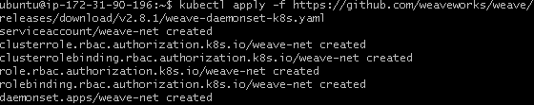

Now execute the below command to see the pods.

kubectl get pods  --all-namespaces

**[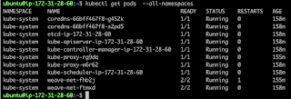](https://1.bp.blogspot.com/-YACO3c3pCOs/Xtgl2QgdNBI/AAAAAAAACdM/wkpe35xXLLIfti25X178kv5FzgY_UO7XwCK4BGAsYHg/kube+pods.png)**

**Now login to Worker Node**

**Join worker node to Master Node**

The below command will join worker node to master node, execute this a normal user by putting sudo before:

sudo kubeadm join <master_node_ip>:6443 --token xrvked.s0n9771cd9x8a9oc \  
    --discovery-token-ca-cert-hash sha256:288084720b5aad132787665cb73b9c530763cd1cba10e12574b4e97452137b4a

[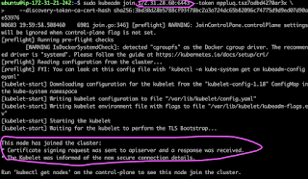](https://1.bp.blogspot.com/-f04_qV2AV-k/XtglKgiYGcI/AAAAAAAACc0/GzgVE6lkV-4oaDpKsAvy2kIvi6GnJZpoACK4BGAsYHg/kube+join.png)

**Go to Master and type the below command**

kubectl get nodes

the above command should display both Master and worker nodes.

[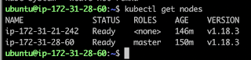](https://1.bp.blogspot.com/-eJe-AXl-79c/Xtgj0JDwKgI/AAAAAAAACcE/Eccj1UX2oPwwKyvLEKsetHQlrOq1S8eWwCK4BGAsYHg/get+nodes.png)

It means Kubernetes Cluster - both Master and worker nodes are setup successfully and up and running!!!